eProject: Carrior motorscars

CARRIO MOTORS CARS

|  |  |  |
| --- | --- | --- |
| **Supervisor.** | MISS HAIQA | |
| **Batch.** | 2207G1 | |
| **Group.** | A | |
| **Serial No.** | **Enrollment Number** | **Student Name** |
| 1. | 1391313 | M.SOALEH |
| 2. | 1392204 | ALIZA REHAN |
| 3. | 1392254 | ALIZA SHAHID |
| 4. | 1392200 | MUHAMMAD HUZAIFA |
| 5. | 1387471 | SUFIYAN SIRAJ |
| 6. | 1391708 | M.RAMIZ ZAKIR |

eProject: Carrior motorscars

# INTRODUCTION

The thirst for learning, upgrading technical skills and applying the concepts in real life environment at a fast pace is what the industry demands from IT professionals today. However busy work schedules, far-flung locations, unavailability of convenient time-slots pose as major barriers when it comes to applying the concepts into realism.  And hence the need to look out for alternative means of implementation in the form of laddered approach.

The above truly pose as constraints especially for our students too! With their busy schedules, it is indeed difficult for our students to keep up with the genuine and constant need for integrated application which can be seen live especially so in the field of IT education where technology can change on the spur of a moment. *Well, technology does come to our rescue at such times!!*

Keeping the above in mind and in tune with our constant endeavour to use Technology in our training model, we at Aptech have thought of revolutionizing the way our students learn and implement the concepts using tools themselves by providing a *live and synchronous eProject   learning environment!*

**So what is this eProject?**

eProject is a step-by-step learning environment that closely simulates the classroom and Lab based learning environment into actual implementation. It is a project implementation at your fingertips!! An electronic, live juncture on the machine that allows you to

* Practice step by step i.e. laddered approach.
* Build a larger more robust application.
* Usage of certain utilities in applications designed by user.
* Single program to unified code leading to a complete application.
* Learn implementation of concepts in a phased manner.
* Enhance skills and add value.
* Work on real life projects.
* Give a real life scenario and help to create applications more complicated and useful.
* Mentoring through email support.

The students at the centre are expected to complete this eProject and send complete project along with the documentation to eProjects Team

Looking forward to a positive response from your end!!

# ACKNOWLEDGEMENT

The first, we would like to express my special thanks of gratitude to my teacher <<MISS-HAIQA>>, who helped us a lot in finalizing this project within the limited time frame, valuable counselling and assistance for the accomplishment of this project.

Secondly we would also like to thank the eProject team at Aptech Head Office, who gave us the golden opportunity to do this wonderful project about Carrior motor cars.

Thirdly, we also thank the eProject team, some of the benefits are as under:

* Re-enforcement of skills happens in the experiential learning process.
* A mentor, ensuring that we do not get drifted, constantly guides us.
* It gives us a lot of confidence to face an interview as we have worked on a project. We can explain virtually everything on the subject we have learnt.we learn how to get your team with same aim but different paths

1

eProject: Carrior motorscars

# SYNOPSIS

Follow the strong development of the internet, technology watches and the growing watch market, every business needs a website design to display products on the internet.

The following era product are designed with many different designs, suitable for all styles and preferences, which are the most special suggestions from Carrior motorscars,we also introduce the models which are approachable by a middle class family which have some vital reasons such that convence issues for a job .

Attached are the introductions hidden behind the watch gift from the gift you want to send to your lover, colleagues or loved ones.

So carrio motors cars shares the best product images through the website for everyone to know.

However, purchases are not made directly on the website

2

# DEFINITION PROBLEM

Carrio Motors is one of the fastest growing Dealerships. We focus on delivering high Customer Satisfaction Standards. All employees are committed to provide service with Discipline, Focus and Speed, by following all Standard Operating Processes defined by our company

Our Dealership's presence is well spread across country with all our showrooms more than 8000 sq. ft. Our Service centers are located strategically to offer best service to our customers. We proudly carry brands such as BMW, Audi, Hyundai, JEEP, Suzuki, Kia, Morris Garage and more.

The company aims to break new ground by harnessing the power of technology and revolutionizing processes to make car ownership for the customers a truly enjoyable and hassle-free experience. So taking into consideration the expanding business, the company planned to host the primary information through its website.

You are supposed to create a Single-Page-Application and responsive Website for them with the below mentioned requirement specifications.

The website is to be developed for the Windows Platform using HTML5, JSON, Angular JS, JavaScript and Geolocation. The site should work well in all leading browsers including Chrome, IE, Firefox etc.

**Functional Requirement Specification:**

The portal will be designed as a Single-Page-Application and responsive Website with a set of pages and menus that represent choice of activities to be performed. The pages, menus, and other visual elements must be designed in a visually appealing manner with attractive fonts, colors, and animations.

All of these should also be laid out in a responsive manner

The Web site is to be created based on the following requirements.

1. The Top of the Page should be presented with a suitable logo and scrolling images of cars.
2. Brand wise categorization of Cars should be provided in the website.
3. Apart from Brand, Performance wise categorization of cars from various brands should be provided.
4. A menu which will include all the functions implemented in the site.
5. Clicking on a car picture should open popup window with car details and specifications. The details include features, price, location of the dealer etc.
6. Site should also include the section that will give the information about the warranty schemes on the cars. The scheme will be different for the different brands.
7. Section for Finance option should be provided. It should list various schemes on different models and brands.
8. Site map, Gallery, about us, Contact us link must be added.
9. About Us and Contact Us: This menu option should display Email id, address, and contact number of the organization.

Over and above this, the portal should implement the following functionalities:

* Display a continuous scrolling ticker at the bottom of the page with current date, time, and location (hint: Use geolocation features of HTML5).
* Display a visitor count at the top right corner of the page beside a logo image.
* The menu options should change color on hover and also after clicking.
* Fade in and fade out options can be used for the menus.

# CUSTOMER REQUIREMENT SPECIFICATION (CRS)

**Hardware/ Software Requirements**

**Hardware**

* Intel Core i3/i5 Processor or higher
* 8 GB RAM or above
* Color SVGA
* 500 GB Hard Disk space
* Mouse
* Keyboard

**Software**

Technologies to be used:

* Frontend: HTML5, CSS, Bootstrap, JavaScript, jQuery, AngularJS, XML
* Data Store: JSON files or TXT files

Other Requirements:

* Operating Portal: Windows
* Browsers: Edge, Chrome, Mozilla Firefox, Safari

4

eProject: Carrior motorscars

# SCOPE OF THE WORK (IN BRIEF)

The website is to be developed for the Windows Platform using HTML5, JavaScript and Geolocation. The site should work well in all leading browsers including Chrome, IE, Firefox etc..

Homepage show Top best sell items, big sale, collection, new shop... Every content direct to relative content.

5

eProject: Carrior motorscars

# AGGREGATED SITEMAP

Carrior motorscars

(0.Welcome.html)

Carrior motorscars English

(1.Index.html)

oject: Carrior motorscars

# SITEMAP ENGLISH

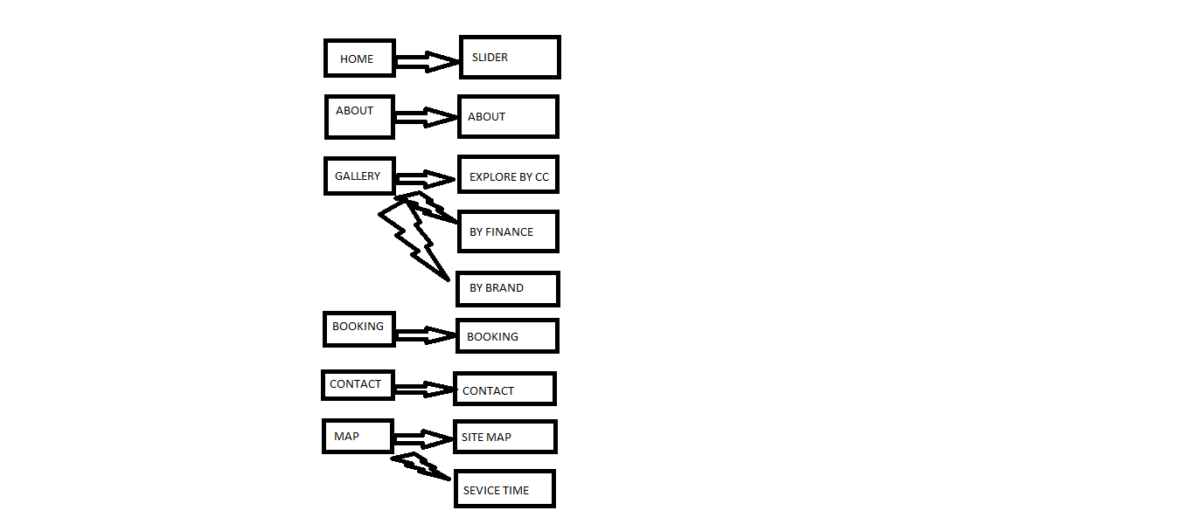

7

1

eProject: Carrior motorscars

# WIREFRAMES

1. Main Layout

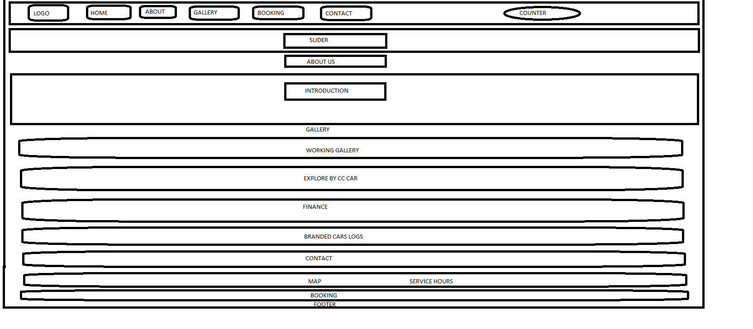

# TASK SHEET REVIEW 1

|  |  |  |  |  |  |  |
| --- | --- | --- | --- | --- | --- | --- |
| Project Ref. No.: eP/Advertisement Portal Management  System/01 | | Project title | Date of Preparation of Activity Plan | | | |
| No | Task | Aura Watch | Actual | Actual | Team-mate | Status |
| Start Date | Days | Names |
| 1 | Build Home | DD/MM/YY | 1 | Student-1 | Complete |
| Page |
| 2 | Build Product Page And  Product Line-Up Pages | DD/MM/YY | 1 | Student-2 | Complete |
| 3 | Build | DD/MM/YY | 1 | Student-3 | Complete |
| Technology,  Support, Store Locator, Register |
| Pages |
| 4 | Build Price Page | DD/MM/YY | 7 | Student-4 | Drop Out |
| 5 | Begin Code  Javascript For The Home Page | DD/MM/YY | 1 | Student-1 | Complete |
| 6 | Begin Code | DD/MM/YY | 1 | Student-2 | Complete |
| Javascript For The Product  Page And Product Line-Up |
| Pages |
| 7 | Begin Code | DD/MM/YY | 1 | Student-3 | Complete |
| Javascript For The Technology,  Support, Store Locator, Register |
| Pages |

13

eProject: Carrior motorscars

|  |  |  |  |  |  |  |
| --- | --- | --- | --- | --- | --- | --- |
| 8 | Begin Code Support For Browsers |  | DD/MM/YY | 1 | Student-1, Student-3 | Complete |
| 9 | Check Progress And Assign New Tasks | DD/MM/YY | 1 | Student-1 | Complete |

14

eProject: Carrior motorscars

# TASK SHEET REVIEW 2

|  |  |  |  |  |  |  |
| --- | --- | --- | --- | --- | --- | --- |
| Project Ref. No.: eP/Advertisement Portal Management  System/01 | | Project title | Date of Preparation of Activity Plan | | | |
| No | Task |  | Actual | Actual | Team-mate | Status |
|  | Start Date | Days | Names |
|  | Check color |  |  |  |  |  |
| 1 | format, size,  javascript, |  | DD/MM/YY | 2 | Student-3 | Complete |
|  | responsive in the |  |  |  |  |  |
|  | Home page |  |  |  |  |  |
|  | Check color |  |  |  |  |  |
| 2 | format, size,  javascript, responsive in |  | DD/MM/YY | 2 | Student-2 | Complete |
|  | Product page and |  |  |  |  |  |
|  | Product Line-up |  |  |  |  |  |
|  | Check color  format, size, javascript, | Aura Watch |  |  | Student-1 |  |
| 3 | responsive in  Technology, |  | DD/MM/YY | 2 |  | Complete |
|  | Support, Store |  |  |  |  |  |
|  | Locator, Register |  |  |  |  |  |
|  | page |  |  |  |  |  |
| 4 | Write a developer guide |  | DD/MM/YY | 2 | Student-2 | Complete |
| 5 | Write user |
| manuals |  |  |  |  |  |
| 6 | Overall inspection of the |  | DD/MM/YY | 2 | Student-2, Student-1, Student-3 | Complete |
|  | project |  |  |  |  |

15